Study Skills:
THIEVES Reading Strategy
Academic Success Center

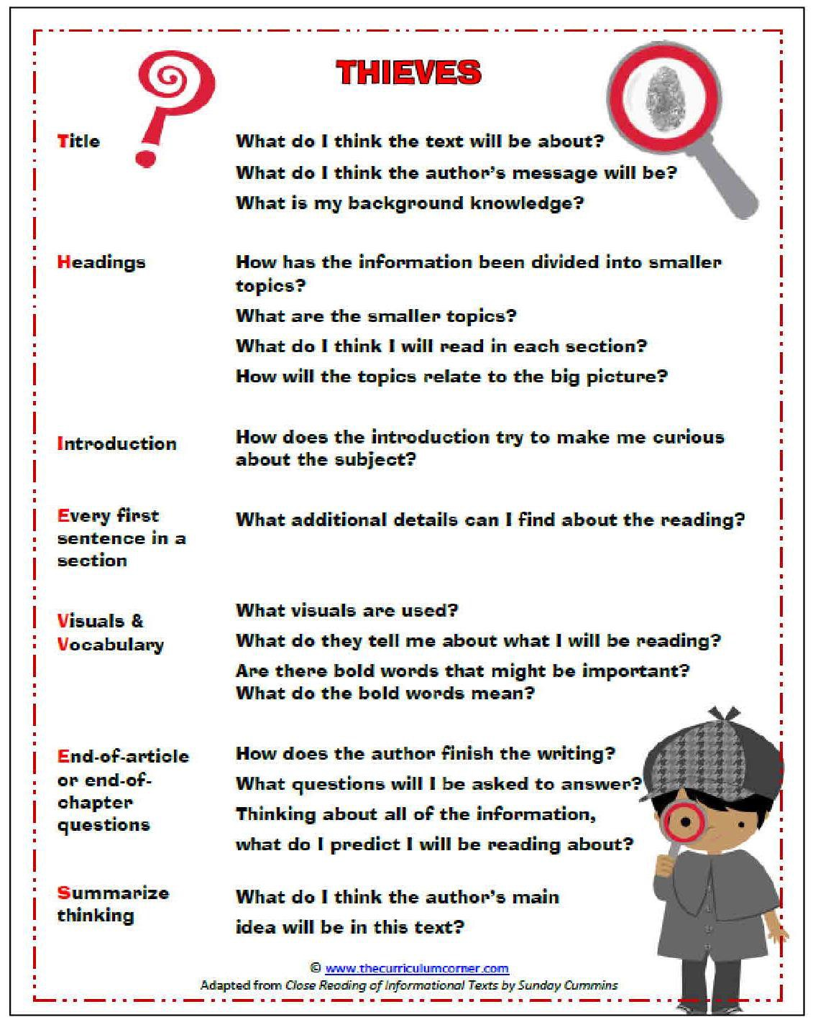

Source: www.thecurriculumcorner.com/

The Academic Success Center is part of the Dean of Students Office at Iowa State University
1060 Hixson-Lied Student Success Center  515-294-6624  success@iastate.edu  http://www.dso.iastate.edu/asc

